**Consuming a Web Service in Java using NetBeans IDE**

This document provides step-by-step instructions to consume a web service in Java using NetBeans IDE. In the project, we will invoke a sorting web service through its WSDL link: <http://vhost3.cs.rit.edu/SortServ/Service.svc?singleWsdl>.

**Prerequisites:**

* NetBeans 8.0 IDE (Can be downloaded from here - [Link](https://netbeans.org/downloads/))

**Step 1: Create a Java Project**

Open NetBeans IDE

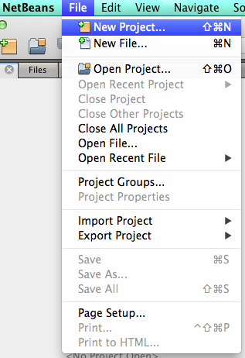Click on New Project and choose Java Application

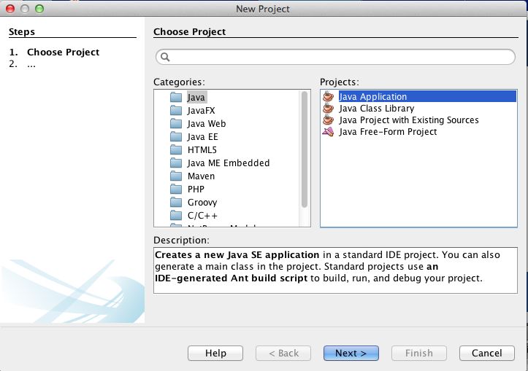

🡪

Enter the Project Name: SortClient, check the option “Create Main Class”, click “Finish”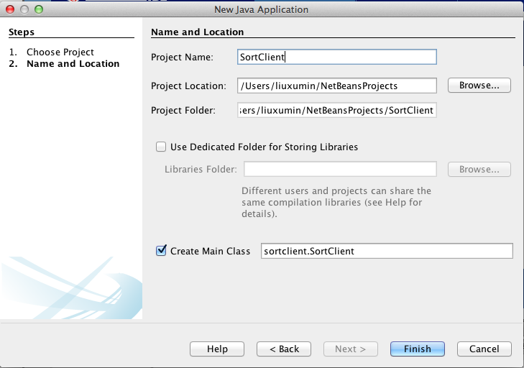

Now the Project has been created.

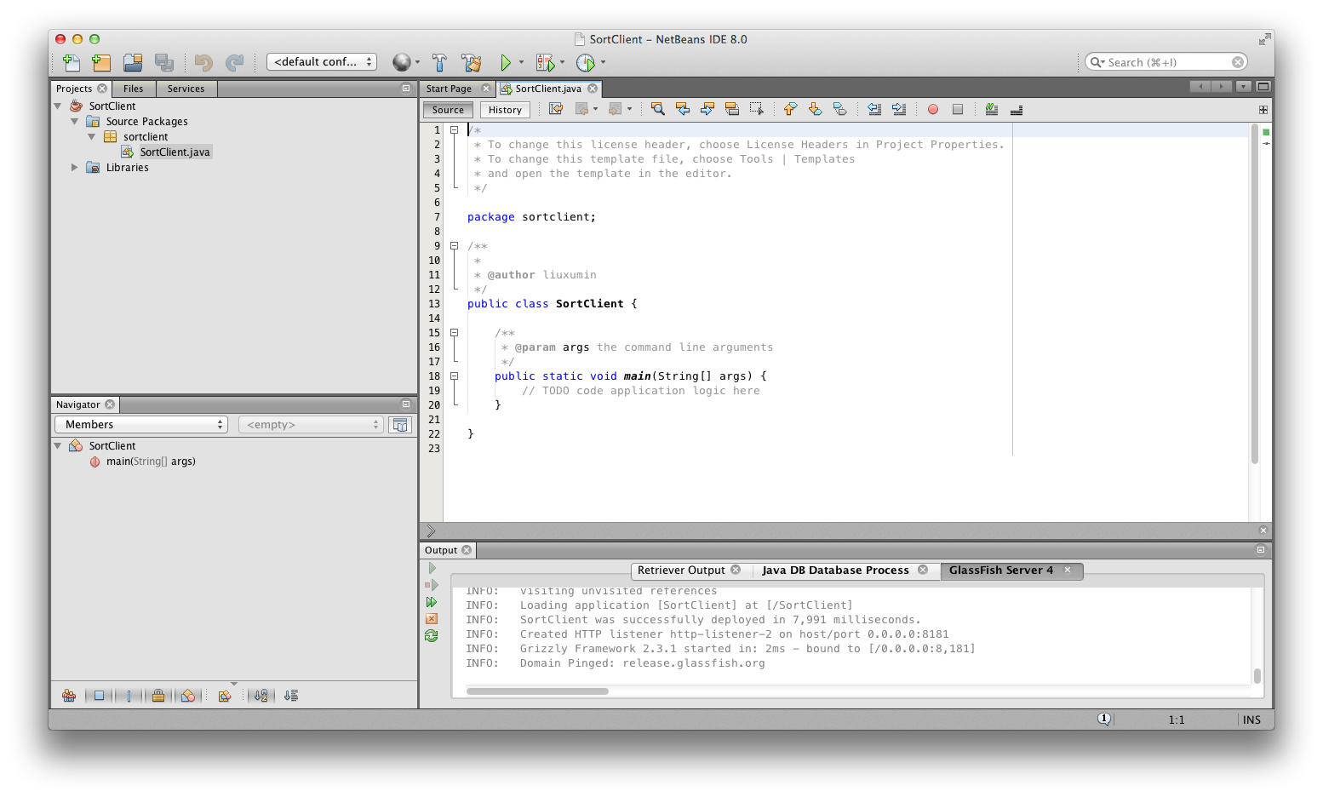

**Step 2: Generate a Web Service Client**

Now go to the Project Tree Structure on the left side of the window.

Right click on Project and select New and then choose Web Service Client

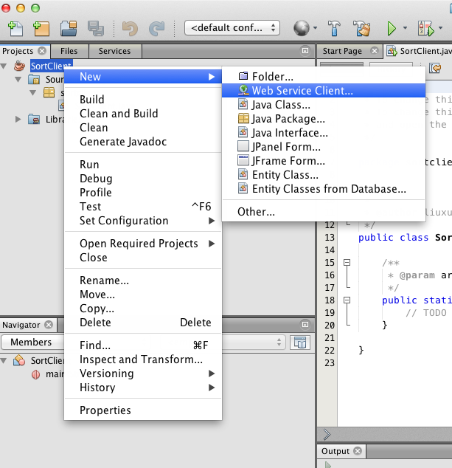

Specify the WSDL URL as: <http://vhost3.cs.rit.edu/SortServ/Service.svc?singleWsdl>

Click “Finish”

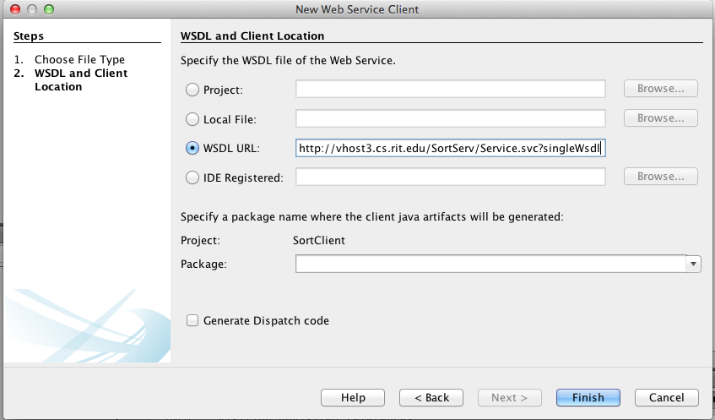

**Step 3: Invoke the Service**

Expand the Web Service References until you see the operation lists. Drag the operation you want to invoke to the source code window, such as “GetKey”. A piece of code is automatically generated to invoke that operation.

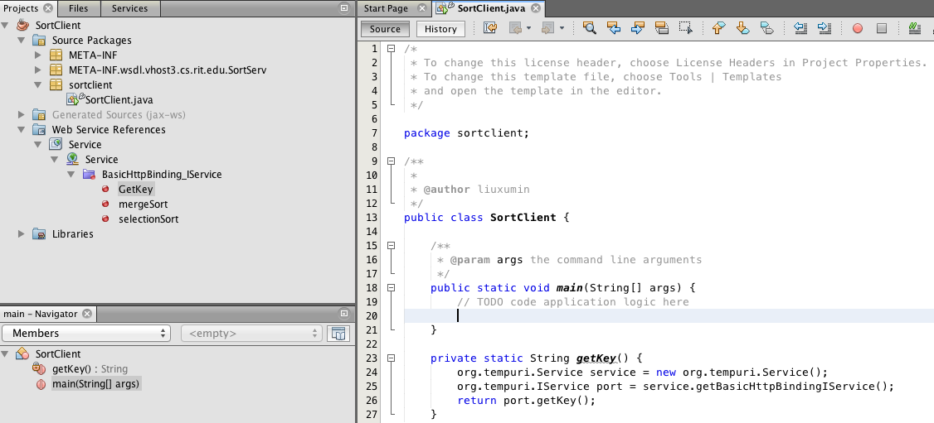

Drag MergeSort to the source code window and the corresponding code is automatically generated, too.

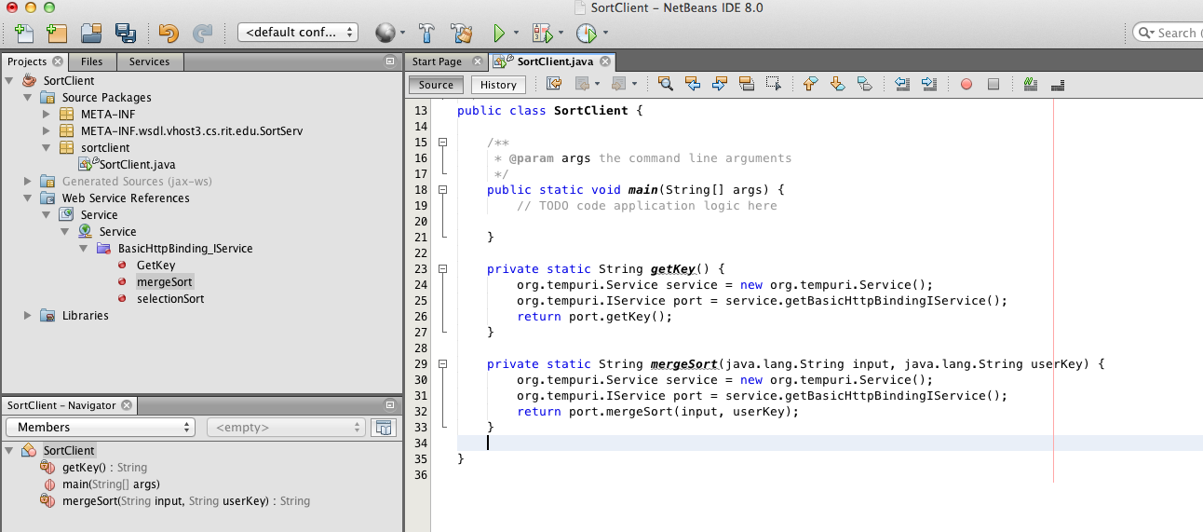

In the main function, add the code to call the two functions: getKey() and mergeSort(); As it is a call to a remote service, RemoteException needs to be listed in the throws cause.

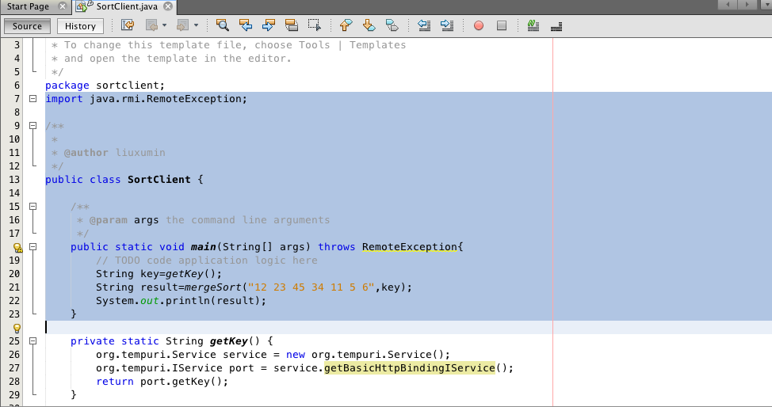

You can also manually generate code like:

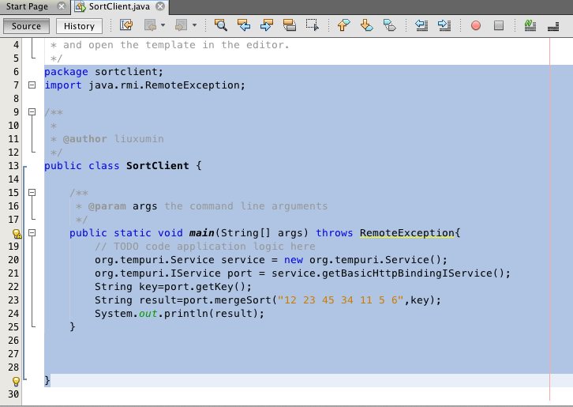

**Step 4: Run the project**

Now run the project and you will get the sorting result.

